CMC NAVY STREAMS DIAGNOSIS
DATED: 03 Aug, 2026
Server 10.51.80.201 (WIN-M7OIAU91N97, Dell, port SLOT 2 Port 2-Recording) is unable to receive multicast stream 239.1.1.7:1111. Diagnostics confirm the server is correctly requesting the stream and the fault lies outside the host — no multicast data is being delivered to the switch port.
What was tested and ruled out on the server
Item | Result
FFmpeg / VLC command syntax | Correct — verified with explicit localaddr binding
NIC binding | Correct — socket bound to 10.51.80.201
IGMP join | Sent successfully (IGMPv2 Membership Report for 239.1.1.7)
Interface selection | Correct — join issued on Interface 12 (QLogic, f4:e9:d4:a1:67:b2)
Windows Firewall | Disabled during testing — no change
Multi-NIC routing conflict | Storage NICs disabled during testing — no change

Proof from packet capture (Wireshark, SLOT 2 Port 2-Recording)
- Server sends a valid join. Packets 9 and 10: 10.51.80.201 → 239.1.1.7, IGMPv2 Membership Report, group 239.1.1.7. The host is correctly requesting the group.
- Network acknowledges the group. Packets 25 and 26: IGMPv3 Membership Query, specific for group 239.1.1.7. Something upstream is tracking this group, so the join is reaching the switch.
- Zero multicast data returns. A capture filtered on all multicast UDP (ip.dst >= 224.0.0.0 && ip.dst <= 239.255.255.255 && udp) returned only 4 packets — all outbound SSDP from the server itself. Not a single inbound multicast packet from any group, including 239.1.1.7. FFmpeg times out with I/O error after 10 seconds.
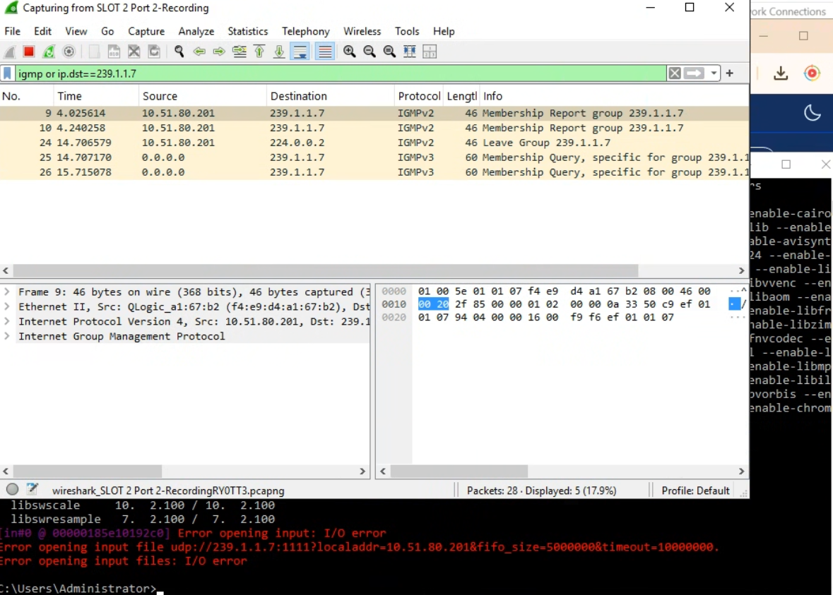
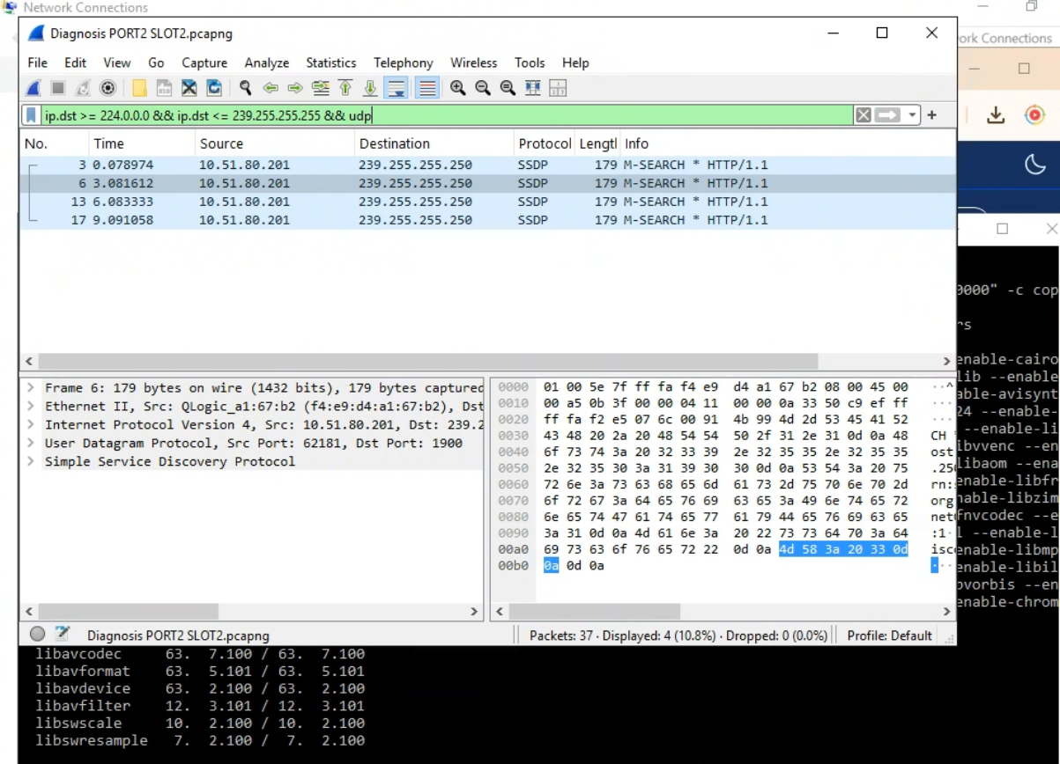

Conclusion: the server joins correctly and the network sees the join, but no stream traffic is ever forwarded to this port.
Two additional observations
- IGMP version mismatch. The server sends IGMPv2 reports while the queries received are IGMPv3. Compatibility mode should handle this, but some snooping implementations fail to program the group correctly under a mismatch.
- Queries originate from source 0.0.0.0. This indicates an L2 switch snooping querier rather than a PIM-enabled multicast router. If the encoder/source is on a different VLAN or subnet, there is no multicast routing to carry the stream into 10.51.80.0/22 — it would never arrive regardless of host configuration.
Requested from the network team
- Confirm the multicast source (encoder/headend) IP and VLAN. If it is outside 10.51.80.0/22, is PIM / multicast routing enabled to reach this subnet?
- Confirm that group 239.1.1.7 is being forwarded into VLAN 10.51.80.0/22.
- Review IGMP snooping configuration and querier placement on the switch port serving this server.
- Confirm the encoder is actively transmitting to 239.1.1.7:1111.
Suggested verification: connect a test machine on the same VLAN (ideally on the encoder's switch) and open udp://@239.1.1.7:1111 in VLC. If it fails there too, the issue is at the source or core network. If it works, the problem is in forwarding toward this server's segment.

